The Hedistar Hotel

🔹 Definition
# Source: ScreenShots Source: Provided by: [Persons Table -> ID Column: 1, Name_En Column: Motasem Essam] -> Tool: [Lightshot Program] -> From [Site: https://hedistarhotel.com/] on [11/15/2025]
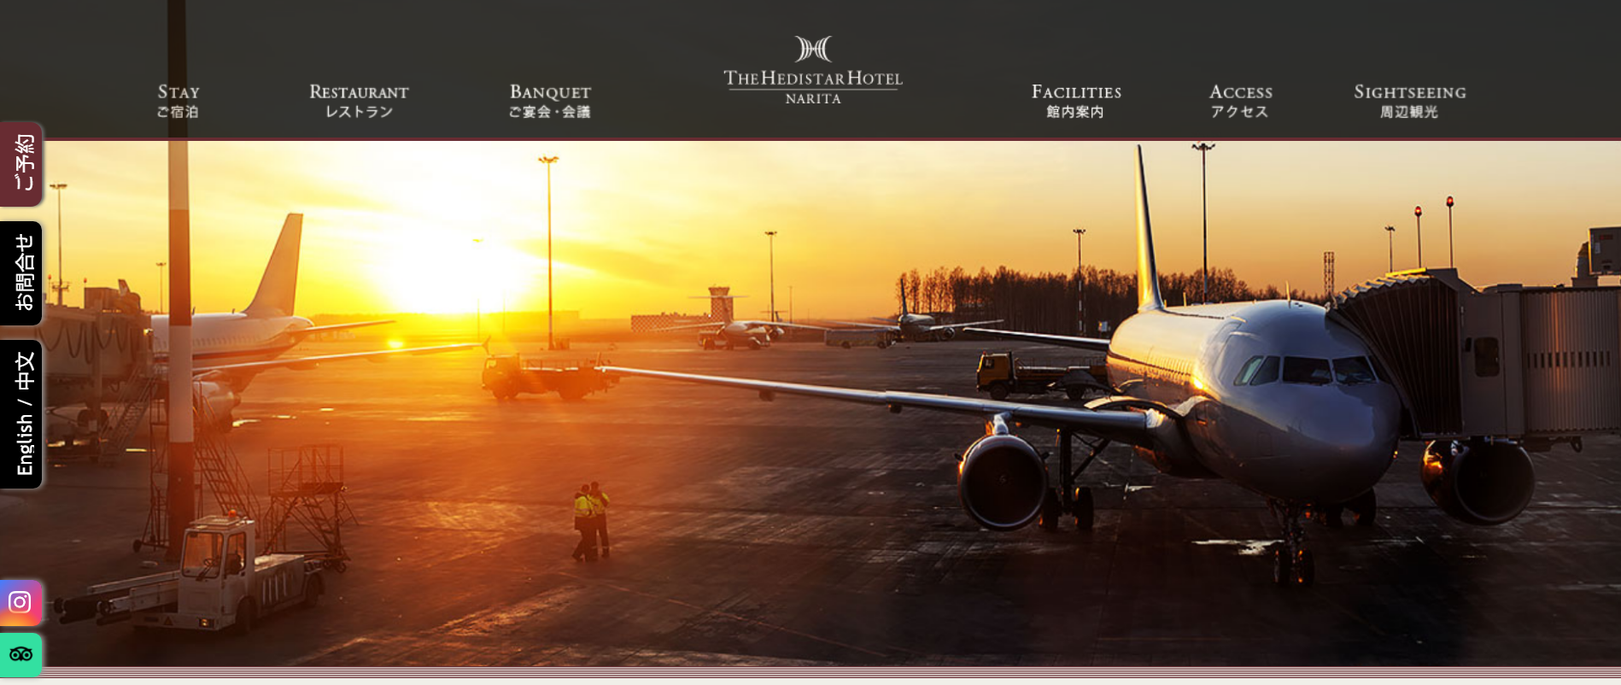
# Source: AI Source: Provided by: [Data Path: Persons Table -> ID Column: 1, Name_En Column: Motasem Essam] -> From: [ChatGPT] on [11/15/2025]
The Hedistar Hotel is a Japanese hotel chain with locations in Narita (Chiba) and Kyoto, Japan. (LOVE CHIBA)
- The Narita location is at 168-1 Azuma-cho, Narita, Chiba. (LOVE CHIBA)
- The Kyoto branch (“The Hedistar Hotel Kyoto Nijo Comic & Books”) includes a manga library with about 10,000 books accessible to guests. (cgman.jp)

🎯 Purpose
# Source: AI Source: Provided by: [Data Path: Persons Table -> ID Column: 1, Name_En Column: Motasem Essam] -> From: [ChatGPT] on [11/15/2025]
- To provide mid-range accommodations for travelers, particularly near Narita Airport so it's convenient for airport stay. (Veronika's Adventure)
- The Kyoto location offers a unique experience by combining hotel stays with a manga/comic book theme and library. (cgman.jp)
- To serve both business and leisure travelers with comfortable rooms, free Wi-Fi, and services like a 24-hour reception. (ZenHotels)

🛡️ Safety & Legality
# Source: AI Source: Provided by: [Data Path: Persons Table -> ID Column: 1, Name_En Column: Motasem Essam] -> From: [ChatGPT] on [11/15/2025]
- It’s a fully legitimate hotel business, part of Core Global Management Co., Ltd. (cgman.jp)
- Standard hotel safety and hospitality regulations apply. There is no indication of any illegal or unsafe activity.
- The hotel is listed on well-known travel and booking platforms (e.g., Booking, TripTap), which provides further legitimacy. (ZenHotels)

📌 Summary
# Source: AI Source: Provided by: [Data Path: Persons Table -> ID Column: 1, Name_En Column: Motasem Essam] -> From: [ChatGPT] on [11/15/2025]
The Hedistar Hotel is a Japanese hotel brand with at least two locations: one in Narita (near the airport) and another in Kyoto (“Comic & Books” hotel), which features a large manga library for guests. It offers a unique blend of affordable lodging and cultural/geek-friendly amenities, making it attractive for travelers who enjoy both comfort and creativity.

